SPEAKER SUMMARY
April 2025
GREG REED, DIRECTOR OF ENGINEERING & TECHNICAL SERVICES - LADWP
STATE OF WATER SYSTEM

By Robert Yoshimura
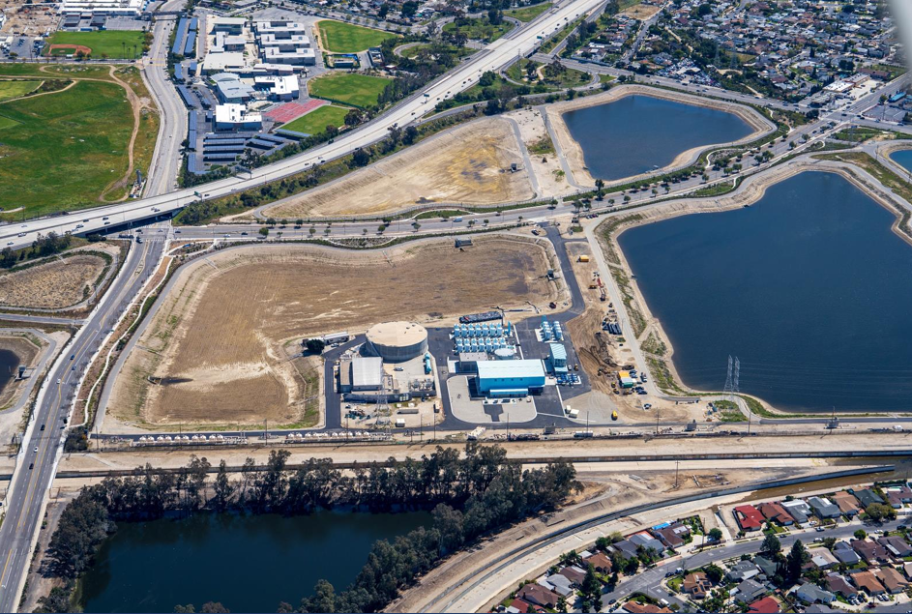
Greg Reed is the Water System manager responsible for the Water Capital Improvement Program (CIP). He provided a summary of the major projects now in progress, as well as an update of the financial issues associated with the cost of implementation of the CIP.

The financial firm of Standard and Poor’s has downgraded the Water System’s bond rating from AA+ to AA- due to perceived risks of financial stress resulting from the recent and likely future fires in Los Angeles. Other bond rating agencies are also evaluating the water side of LADWP and they may follow suit as well. Such downgrading is likely to increase future costs of borrowing, which may affect the cost of capital projects.

The Water System has not had a rate action since 2016. One was planned for 2020 but never implemented because of the Covid pandemic that significantly changed political priorities at that time. The Water System is currently working on an estimate of future revenue requirements for which the CIP will exert a significant amount. It is also considering rate restructuring as well as rate changes to fulfill such future revenue requirements. Because California’s constitution requires that utility rates be based on the actual cost of service, the Water System is planning to hire a consultant to perform an assessment of such costs to input into the rate case.

The Water System is actively and aggressively pursuing external sources of revenue for its CIP, with particular emphasis on California Proposition 1 (2014 Water Bond) grant funding. The city of Los Angeles’ lobbyists in both Washington DC and Sacramento are presenting their cases for additional federal and state funding as well. Such external funding will be needed because the size and cost of the CIP has grown significantly in recent years and unexpected cost escalations have occurred on many recent projects.

The Capital Improvement Program. The system-wide CIP is estimated at $800 million for 2025 of which $300 million is under the control of Water Engineering and Technical Services (WETS) Division. A brief description of each project in the water CIP is provided below:

- Fairmont Sedimentation Plant (see rendering below), to be located upstream of the Los Angeles Aqueduct Filtration Plant (LAAFP) is needed to improve raw water quality by reducing turbidity and arsenic levels to reduce the burden on the filters and improve operational flexibility of LAAFP. The plant is being delivered via a progressive design-build process and a contract has been awarded for $850 million.
- The System-Wide Chloramination Trailer project is needed to maintain a chloramine residual in tanks susceptible to stagnation which results in chloramine loss. 11 pre-packaged residual control stations with remote monitoring in trailers will be installed at 11 tanks.
- The $514 million Tom LaBonge Headworks Complex and the $289 million River Supply Conduit (RSC) Upper Reach are nearly complete. The two reservoirs (110 MG combined) are operational, and the flow control station will be commissioned in June 2025. The Headworks Restoration Project (a passive use park atop the West Reservoir) will begin the design phase this month. The RSC pipelines are complete, and the disinfection station will begin operating also this month.
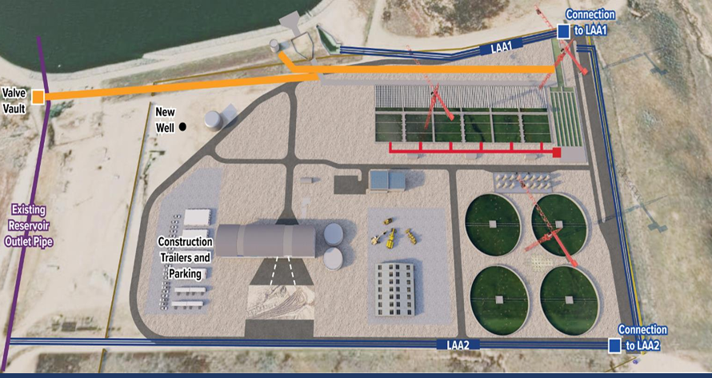
- The $185 million North Haiwee Dam No. 2 is needed because the existing dam is seismically unsafe, and if lost, will disable the operation of the Aqueduct for many months.
- The $30 million Redmont Tank and Pumping Station will replace the existing reservoir with a 436,000-gallon steel tank and dual pumping station to serve anticipated future demands and boost fire-fighting capacity.
- Trunkline Replacements – Both the $180 million Western Trunkline and the $300 million Roscoe Trunkline (to replace the aging City Trunkline) have been recently awarded. Both projects replace aging trunklines with seismically secure facilities.
- The DeSoto Tanks project will replace the existing 3 MG reservoir with two tanks of 20 MG capacity total. The expected completion date is December 2031 and will cost $120 to $180 million.
- San Fernando Basin Groundwater Treatment Facilities are needed to remove a variety of organic chemicals from groundwater. Three projects have been completed and are nearing commissioning: North Hollywood West ($137.6 million), North Hollywood Central ($255 million), and Tujunga Central ($292 million). Recently, PFAS (per- and poly- flouro alkyl substances) were detected in the water to be treated by the Tujunga Central Plant. DWP is exploring different types of granular carbon media to resolve the problem. Some additional treatment processes may also have to be added. When operational, these facilities will provide nearly 200 cubic feet per second of capacity, which will significantly add to DWP’s drought water supplies.
- The $740 million Groundwater Replenishment Project (GRP) will produce up to 22,000 acre-feet per year of recycled wastewater from the Tillman Reclamation Plant for groundwater replenishment via spreading at Hansen Spreading Grounds.
- Pure Water LA Project, which has been thoroughly described by previous speakers at this Board, will recycle nearly all the effluent from the Hyperion Water Reclamation Plant. The estimated cost is $21 to $26 billion.

In addition to the projects described above, Greg Reed’s presentation slides included four additional projects including the $207 million Water Quality Laboratory, the $432 million Mid-Valley Water Facilities Yard, the $510 million Western District Yard Renovation, and $72 million San Fernando Valley Chlorination Upgrades. The magnitude of the CIP is thus immense and will present a significant challenge to the Water System.

